RIPHAH INTERNATIONAL UNIVERSITY ISLAMABAD
I-14 CAMPUS


SEMESTER PROJECT
Instructor: Mr Islam Abasi

Course: Software Construction & Development
Section: BSSE5-1
Semester: 5th
NAME SAP ID
Malik Usama 56340
Rana Anees 47016

Software Requirement Specification
Title: Link City System
- Introduction
Link City System is an application that helps people in the city connect and get information easily. Through this app, people can view local news, report problems like broken roads or power outages, and find nearby services. The app is available on both mobile and web platforms, making city-related information clear and simple.
- Stakeholders
- Resident
- Business Owner
- City Official (Admin)
- Functional Requirements
- For Residents
- Residents shall be able to see daily news and updates about their area.
- Residents shall be able to easily report problems like bad roads or power outages.
- Residents shall be able to search for products, services, or businesses by name, category, or location.
- Residents will receive notifications about their reports or updates.
- Residents shall be able to give feedback and report incorrect information.
- Residents will get suggestions based on their location and interests.
- For Business Owners
- Business owners shall be able to add details about their business and products.
- Business owners will be able to reply to customer feedback and comments.
- Business owners shall be able to see data about their business reviews and feedback.
- For Admins
- Admins shall be able to approve or reject reports and business information.
- Admins will be able to manage users, businesses, and categories.
- Admins shall be able to create daily or weekly reports.
- Admins will be able to edit or delete wrong or harmful information.
- Admins shall keep records of all updates and reports for transparency.

Artifact #01
Use Case Diagram

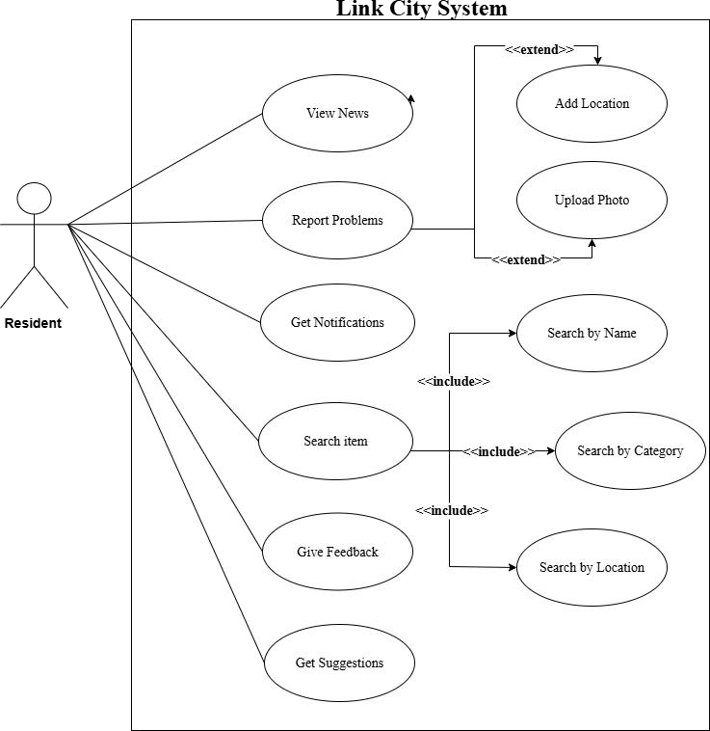
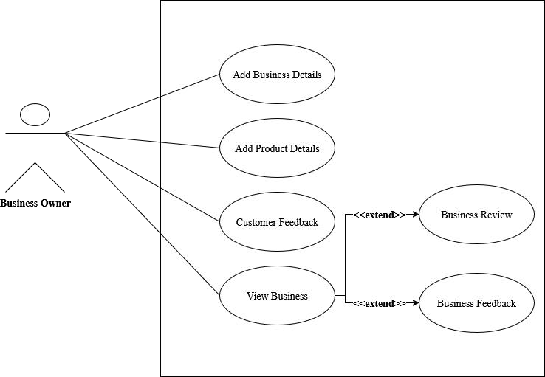
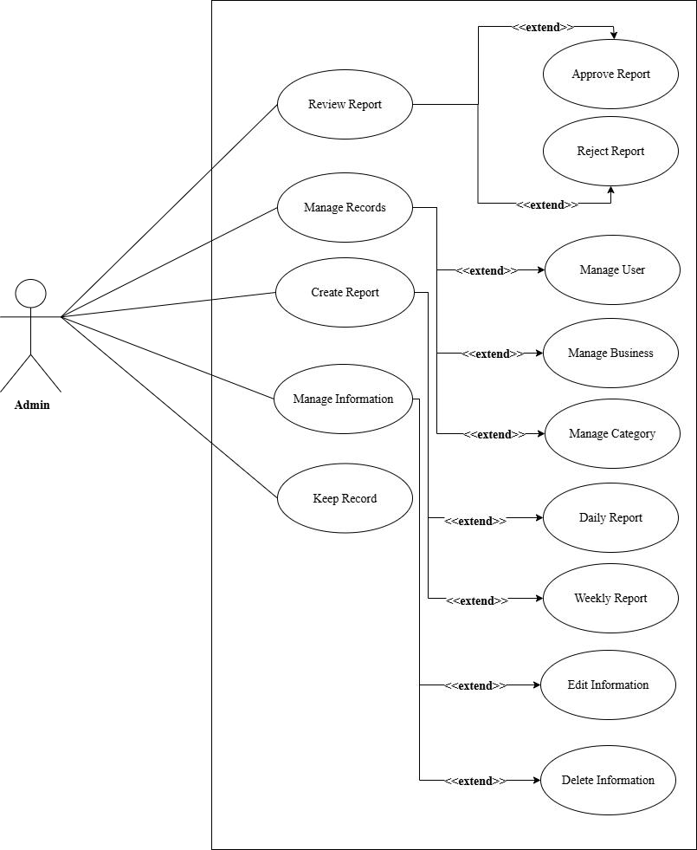

Artifact #02
Fully Dressed/Expanded

